ICE 3 – Import and Merge csv data files in MS SQL (35pts)

Elaine da Silva, w0445885,

November,2024

Please create an SSIS Package to accomplish the following:

1. Add/Update all Province data if the API data do not match the stored in the Database.

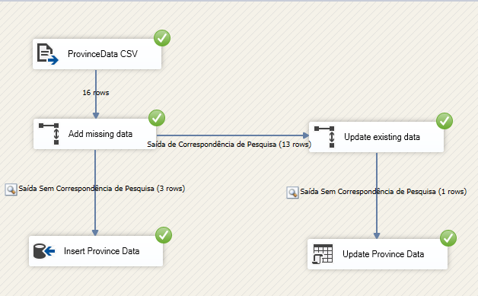

1. Add/Update all Covid data if the API data do not match the stored in the Database.

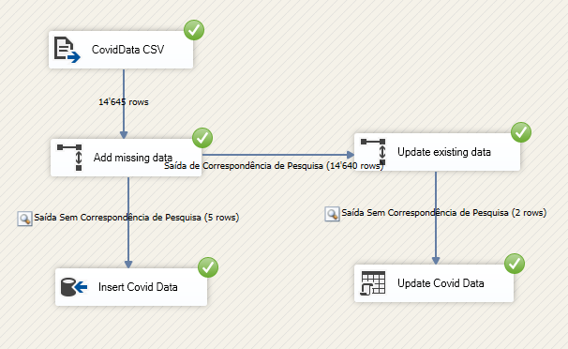

1. Please submit a screen capture of your Data Flow (15pts) [same as above], and your Flow Control.

**Observation:**

1. The only way to make my flow works completely was change the precedence of “*Import Covid Data*” coming from “*Import Province Data*” as below. Otherwise, one of importation failed because *CovidData* depends on *ProvinceData* to be populated.

I researched about how to fix the issue without success. So, I used this resource of changing the precedence as a work around.

I tested the flow using all the possible scenarios: changing values in both tables and deleting a row in both tables. The flow works perfectly.

1. I disabled the DELETE DATA activity to let the wrong data in the table. Otherwise, the data will be deleted and the merge will not be effective.

